

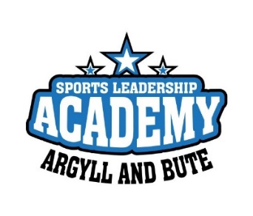
Active Schools Sports Leaders Academy - Application Form
Please hand to your Active Schools Coordinator or e-mail to activeschools@argyll-bute.gov.uk by Monday 24th June (Last Monday before the holidays)
If you have any questions, please contact your Active Schools Coordinator
Contact Information
First name: Last name:
School:
Date of birth : Age:
Male or Female:
Address:
Postcode:
Mobile Number: E-mail address:

What volunteering do you currently do?

Why would you like to take part in the Sports Leadership Academy?

What sports/activities would you like to gain qualifications in as part of the Academy?

If you are successful in gaining a place on the programme, what size of t-shirt do you require? Size: XS S M L XL

Return this application to your Active Schools Coordinator, or activeschools@argyll-bute.gov.uk by by Monday 24th June (Last Monday before the holidays)

