August 2025 Flash Fiction Results – Pirates theme
Judging was delayed due to holidays and then an extra judge had to be drafted in as we had a 3-way tie.
The winner is ….
Pirates by Hunter McAuley
The two tattooed pirates cautiously eyed the small island and debated whether to land. ‘I say we go for it’ said Fast Freddy. Jumping Jack frowned. ‘I’m not sure, what if there are hostile tribes and fearsome creatures?’ Freddie sighed. ‘We’re pirates, remember, we’re supposed to be brave and adventurous.’ Jack’s brow furrowed. ‘You saying I’m a coward?’ Freddy stood tall and thrust his chin out. ‘What if I am?’ Jack bristled and squared up to him. They stared hard at each other. ‘Then how do we settle this?’ Freddy nodded knowingly. ‘The only way pirates know how matey, with our cutlasses.’
Jumping Jack stared hard at Fast Freddy for some moments before answering. ‘Ok then, I’m up for it.’ They both pulled on their hats and checked their scabbards. Tiny beads of sweat trickled down both foreheads. ‘The rules?’ asked Jack. Freddy shrugged. ‘There are no rules, we’re lawless criminals of the sea.’ ‘This is our duel, we make the rules’ countered Jack. ‘Such as?’ asked Freddy, a sneer wrinkling his face. Jack raised his open hands. ‘I Dunno, three strikes and you’re out?’ Freddy laughed mirthlessly. ‘More like one strike will do matey! but if you agree then three strikes it is.’ Jack placed his hand on his cutlass. ‘And the spoils?’ Freddy grinned. ‘We go ashore, and the winner has pick of the plunder.’
Both sets of eyes narrowed as they sized each other up. A fine drizzle started falling, dampening their shoddy attire. Suddenly, without warning, Fast Freddy moved first, a rapier thrust at Jack’s midriff. Jack swerved and dodged the blow, at the same time striking out for Freddy’s loaded arm. And so, the duel commenced with move and counter move until Freddy made the first hit on Jack’s leg. Jack let out a howl of anguish and the intensity of the fighting got fiercer. Both faces were flushed with blood and sweat as they thrust and counter thrust at each other. Neither gained a clear upper hand, and after another ten minutes of intense duelling they called a truce at two hits each, neither wanting to lose.
Exhausted, the two combatants collapsed in a heap, breathing hard and trying to catch their breath. Freddy offered his hand. ‘A draw?’ Jack smiled, and they firmly shook hands. They both gazed over at the small, green island. ‘Maybe some other time we’ll go for it, eh?’ said Freddy. ‘Yeah, fine by me’ agreed Jack. They took their hats off and put the cutlasses away. Jack fumbled in his pack before announcing ‘It’s lunch time, I’m going home for something to eat.’ ‘Me too’ replied Freddy, ‘I’m starved.’
‘The pirates of the boating pond’ joked Freddy, ‘do you think Johnny Depp will be worried?’ ‘He should be’ Jack replied, ‘that was some performance, and with cardboard cutlasses too!’ They both burst out laughing and headed home for lunch, oblivious to the falling drizzle.
The (very, very close) runners up ….
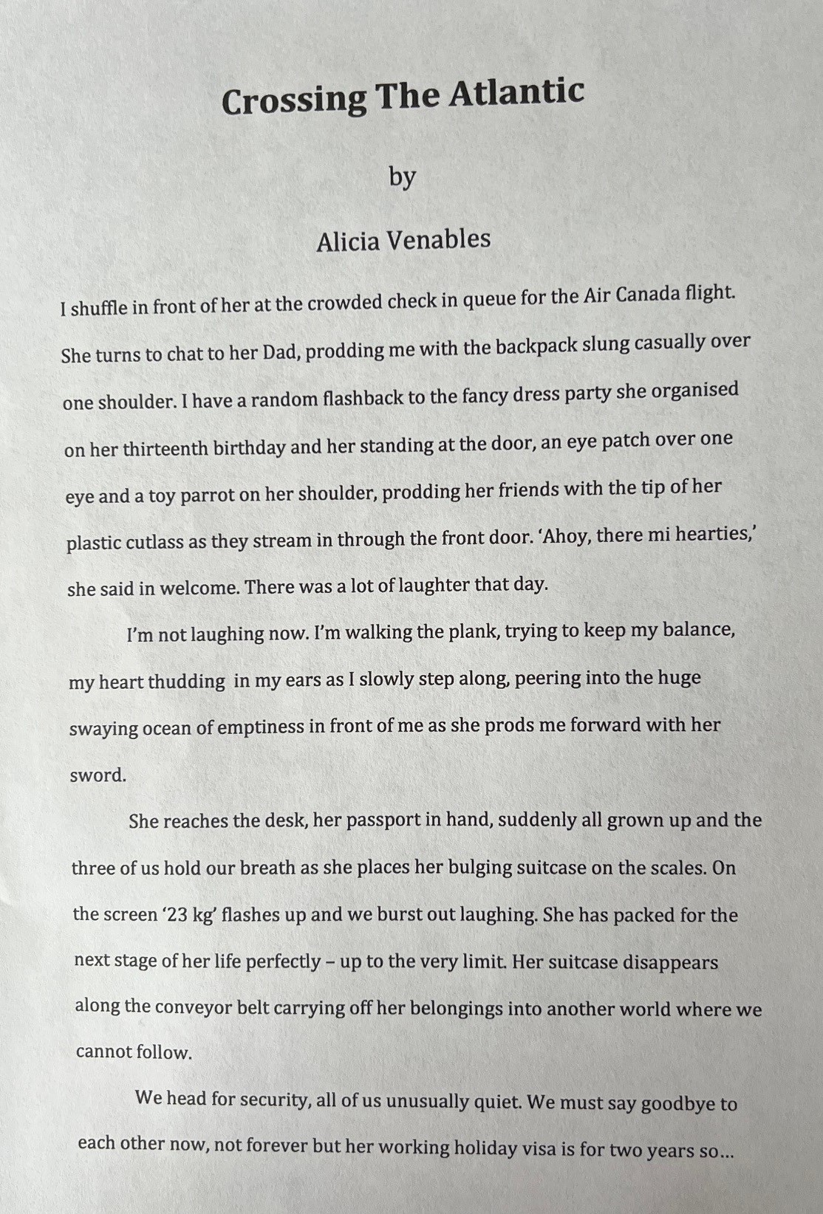
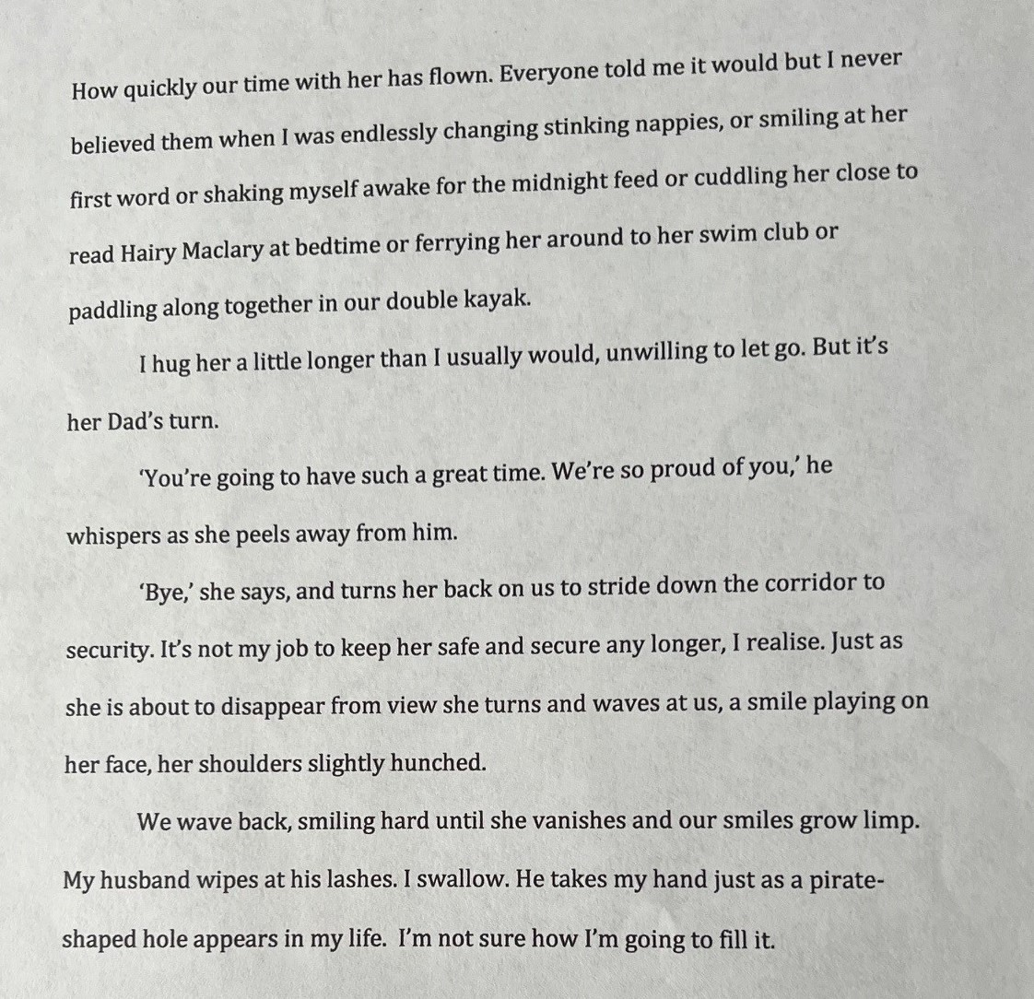
And…
Pirate Raid by Janet Armstrong
Heavy rain signalled the end of summer, and the fair had made its way to the Wee Toon. But as soon as the rain slackened, the staff wasted no time. A towering Ferris wheel began to spin, and gaudy side stalls appeared at its feet. But the stars of the show were the bumper cars, borne on a vast platform emblazoned with the words: SURF ‘N SMASH.
On the rooftops, a scrappy crew of herring gulls had gathered, eyeing the commotion with anticipation. Feathers flapped, webbed toes shuffled, and beaks snapped as two men wheeled out a caravan. A one-legged gull perched tall on a chimney stack, strained a beady eye, and let out a rasping screech.
“SNACK STAND,” shrieked Long John Feathers, craning his neck for a better view. Years ago, he’d lost a leg during a hasty retreat from a sandwich bar, but what he lacked in speed, he made up for with a sniper’s eye and blade-like wit. He was always the first to spot a target, and today, his gaze locked onto something promising. The steady whirr of a petrol generator thrummed from the green – a sure sign the chip fryer had been fired up.
Screeches ricocheted around the toon’s eaves in an off-key chorus. Wings soared high, transforming the sky into a downy duvet of expectation. Even the pigeons had their beaks on full throttle, soaking up the ruckus.
“CALM DOWN YOU LOT!” came a raspy, low-pitched squawk with the air of one in authority. Amid the chaos, Captain McBeaky had perched unnoticed atop the SURF ‘N SMASH sign, scanning the scene, waiting.
“Aye-aye, Sir!” shrieked Scurvy Steve from a lamppost, echoed by his lifelong mate, Chipfat Kate. The birds began to settle around the fair’s perimeter. Every bird in the peninsula had pitched up. Even Mad Gull MacDuff and Bad-eye Breadcrust had flown in from a stake out at the ferry terminal.
Families began to arrive as music pumped across the green. The aroma of deep-fried cod and vinegared chips had proved irresistible, and visitors swarmed to the snack stand.
Wee Isla McGregor’s face lit up as the man in the snack van handed her a tray of crispy chips. She dug a little wooden fork into the fattest one and opened her mouth.
But before Isla could taste her prize, Long John Feathers, his single leg tucked for speed, barrelled down from his chimney pot. Chipfat Kate flanked him to the left, and Scurvy Steve spiralled in from the right with a fearsome battle cry.
Isla gazed wide-eyed as a blur of feathers executed the raid with military precision. Captain McBeaky raised a victorious wing atop the snack stand, and his crew each seized a chip and soared away, leaving barely a crumb in their tracks. A commotion by the quay had caught their attention—the Silver Gull was unloading its catch—and amid a blizzard of beaks and a flurry of feathers, the pirates flew off to their next raid.
Commendable mentions must also go to Alan Carter, Stewart Devitt and Julie Forrester whose entries were all only one point behind.
Well done all!

