Live Argyll - Flash Fiction 500 December 2025
The winner is Margaret McKendrick…..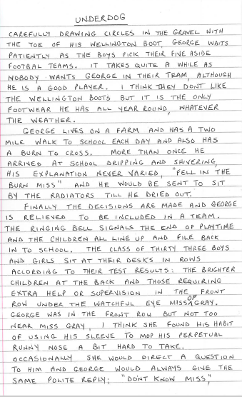

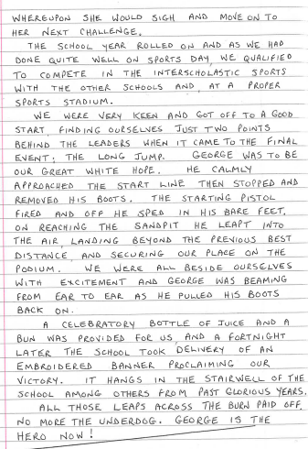
Closely followed by ….
Wunderdog by Carole McAuley

Having lost her husband, her dog, plus dealing with a myriad of other cruel blows large and small over the last few years, Mary could be forgiven for thinking that life had it in for her but yet she still retained her sense of humour. She thought if she’d been a soap opera character, she’d be the unluckiest one ever, her name being synonymous with underdog. Little did she know, her luck was about to change …

In a nearby rescue centre lived a lonely dog called Jack, just waiting for someone like Mary. In the feel-good movies, two such characters would eventually meet (often about Christmas-time!), and it would be happy ever after, and the credits would roll, the audience delighted that good things do happen to good people. Jack’d been in a succession of homes. His first owner had to move to a flat where dogs weren’t allowed. Then his second owners got divorced, neither being interested in contesting his custody. The next lot took him because they couldn't find a puppy and when they did get one they decided they didn’t want two dogs, so back came Jack. Prospective owners constantly passed him over, he wasn’t especially cute or so ugly that someone would take pity and adopt him. Unable to face another rejection, he retreated into himself. He lay in his basket, never coming to the bars of his cage to inspect any visitors, he didn’t know what people were looking for but he knew it wasn’t him.

Following some wound-licking of her own, Mary felt ready to look for another dog. Obviously her first port of call was the local rescue centre, never seriously expecting to meet her match there. The centre manager showed Mary the dogs awaiting adoption. They were all barking, bouncing up and down, in doggy desperation “ME, ME, ME, YOU WANT ME!” Jack of course was not partaking, this visitor wouldn’t be any different. Mary looked over, seeing him curled in his basket, his back to all the cacophony. “Who’s that?” she asked. “Jack” the manager replied “he’s ended up back here several times, none of it his fault, a poor wee underdog, and he’s just given up. I’d take him myself but I’ve already got two dogs”. Mary’s interest was well and truly piqued. She went over to his cage, and whispered softly to him: “Hi Jack, I’m Mary. I’m one of life’s underdogs too, what do you think about coming home with me?” Jack turned his head round and their eyes met, his tail starting to wag ever so slightly. He made his way over, sniffing her hands through the bars. The centre manager was speechless, Jack had never done that before. “From underdog to my Wunderdog!”, declared Mary. “Brilliant!” replied the manager, “I’ll start the paperwork and home-checks and you’ll have him home by Christmas!” Yes, proof that good things happen to nice people (and nice dogs), and it’s even better when they happen at Christmas!

