Live Argyll - Flash Fiction 500 – August 2026
The winner for the “cliff” theme is …..
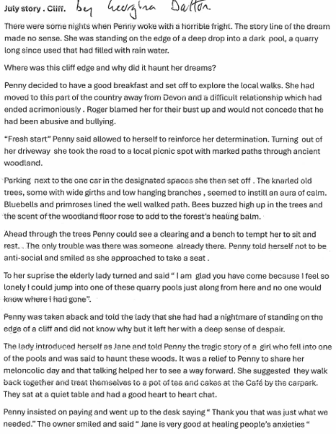
The runner-up was ….
Margaret McKendrick
